**Chapter 1 Introduction to Project Management**

4 core knowledge areas of project management :

1 Project scope

2 time,

3 cost

4 quality management

4 facilitating knowledge areas:

1 human resource

2 communications

3 risk

4 procurement management

9 knowledge areas:

1 scope management

2 Time management

3 Cost management

4 Quality management

5 Human resource management

6 Communications management

7 Risk management

8 Procurement management

9 Project integration management

Advantage of using formal project management?

1 Better control of financial,physical,and human resources

2 improved customer relations

3 shorter development times

4 lower costs and improved productivity

5 higher quality and increased reliability

6 higher profit margins

7 better internal coordination

8 positive impact on meeting strategic goals

9 higher worker morale

What is a project?

A project is “a temporary endeavor undertaken to create a unique product,service,or result.”

Project attributes

1 a project has a unique purpose

2 a project is temporary

3 a project is developed using progressive elaboration

4 a project requires resources,often from various areas

5 a project should have a primary customer or sponsor

6 a project involves uncertainty

The triple constraint of project management：Scope,time,cost

Constraint           Importance

**Time**               The time constraint refers to the amount of time available to complete the

                     project. A tight time constraint could mean increased costs and reduced

                     scope.

**Cost**                The cost constraint refers to the amount of budget available to complete the

                     project. A tight cost constraint could mean increased time and reduced

                     scope. **Scope**               The scope constraint refers to what must to be done to produce the project's

                     end result. Scope is based on customer's requirements. Increased scope means

                     increased time and increased costs.

Figure 1-1

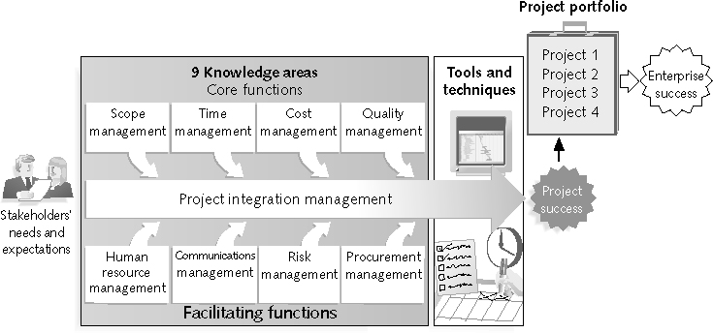

Figure 1-2 Project management framework

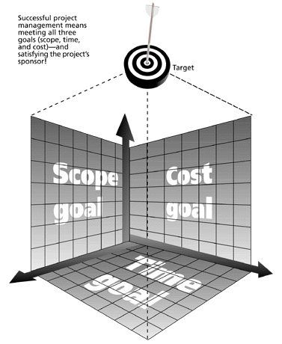

**Suggested Skills for Project Managers**

* The Project Management Body of Knowledge
* Application area knowledge, standards, and regulations
* Project environment knowledge
* General management knowledge and skills
* 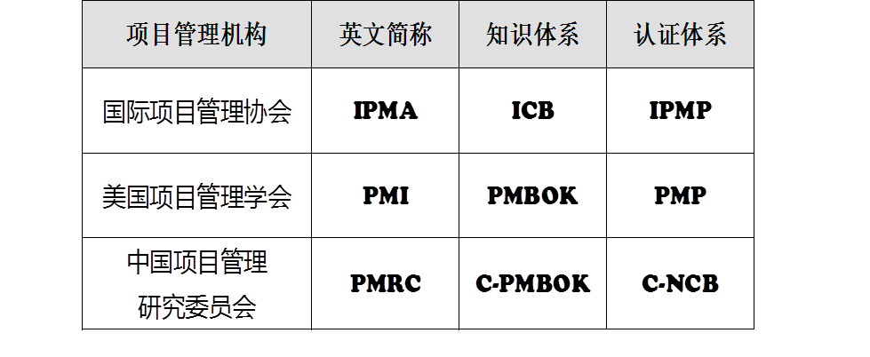Soft skills or human relations skills

**Project Management Certification**

* PMI provides certification as a **Project Management Professional** (**PMP**)

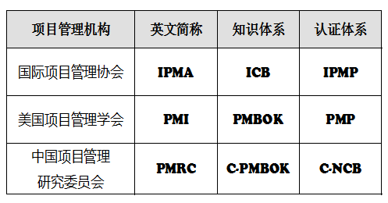

Chapter 2 **The Project Management and Information Technology Context**

**Project Phases and the Project Life Cycle**

* A **project life cycle** is a collection of project phases that defines:
  + What work will be performed in each phase
  + What deliverables will be produced and when
  + Who is involved in each phase
  + How management will control and approve work produced in each phase

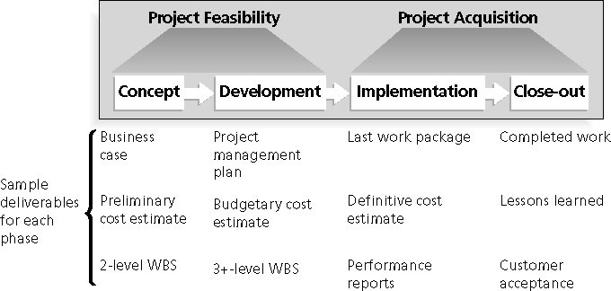

**Figure 2-3. Phases of the Traditional Project Life Cycle**

**Product Life Cycles**

* **Products also have life cycles**

**Predictive Life Cycle Models**

* Waterfall model: has well-defined, linear stages of systems development and support
* Spiral model: shows that software is developed using an iterative or spiral approach rather than a linear approach
* Incremental build model: provides for progressive development of operational software
* Prototyping model: used for developing prototypes to clarify user requirements
* Rapid Application Development (RAD) model: used to produce systems quickly without sacrificing quality

**Chapter 3: The Project Management Process Groups: A Case Study**

The project management process groups include:

* + Initiating processes
  + Planning processes
  + Executing processes
  + Monitoring and controlling processes
  + Closing processes

**Figure 3-4. JWD Consulting Intranet Site Project Baseline**

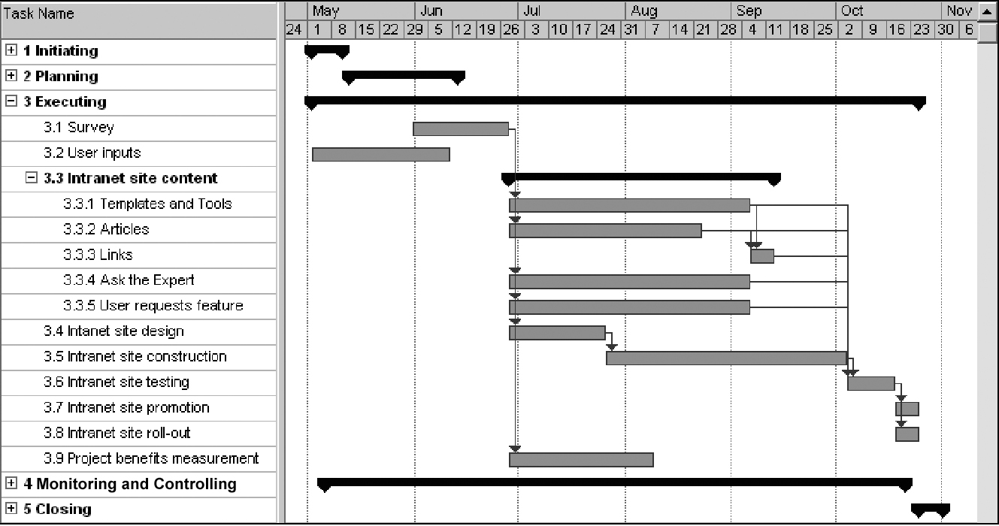

**Chapter 4: Project Integration Management**

**Project Integration Management Processes**

* **Develop the project charter**: working with stakeholders to create the document that formally authorizes a project—the charter
* **Develop the project management plan**: coordinating all planning efforts to create a consistent, coherent document—the project management plan
* **Direct and manage project execution**:carrying out the project management plan by performing the activities included in it
* **Monitor and control the project work**: overseeing project work to meet the performance objectives of the project
* **Perform integrated change control**: coordinating changes that affect the project’s deliverables and organizational process assets
* **Close the project or phase**: finalizing all project activities to formally close the project or phase

**SWOT analysis**

Analyzing **S**trengths, **W**eaknesses, **O**pportunities, and **T**hreats

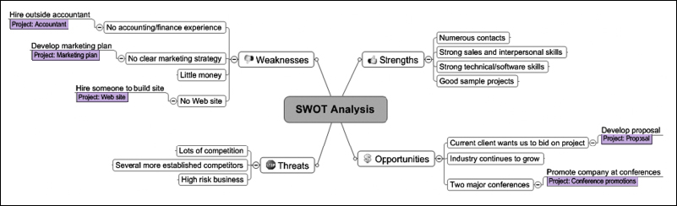

**Figure 4-3. Information Technology Planning Process**

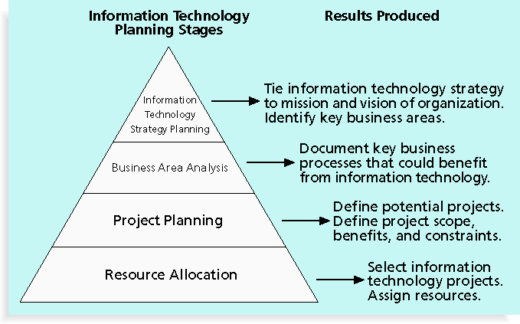

* Three primary methods for determining the projected financial value of projects:
  + Net present value (NPV) analysis
  + Return on investment (ROI)
  + Payback analysis

**Net Present Value Analysis**

* **Net present value** (NPV) analysis is a method of calculating the expected net monetary gain or loss from a project by discounting all expected future cash inflows and outflows to the present point in time
* Projects with a positive NPV should be considered if financial value is a key criterion
* The higher the NPV, the better

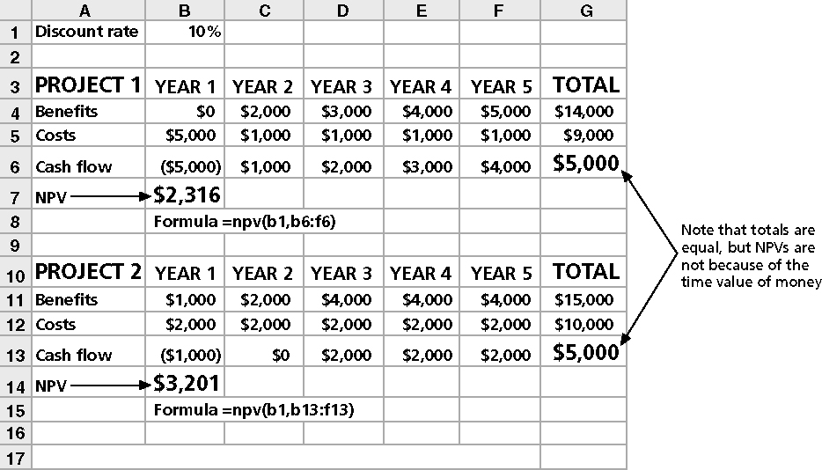

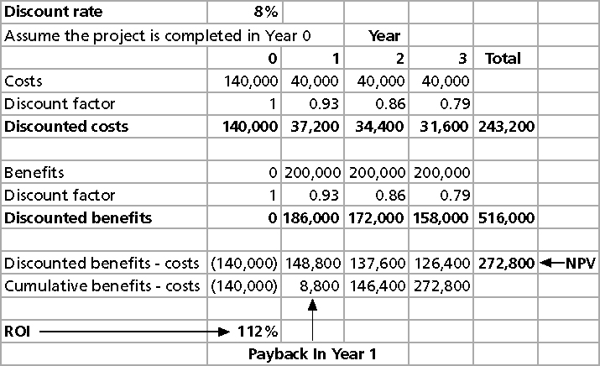

**Chapter 5: Project Scope Management**

**Project Scope Management Processes**

* **Collecting requirements: defining and documenting the features and functions of the products produced during the project as well as the processes used for creating them**
* **Defining scope: reviewing the project charter, requirements documents, and organizational process assets to create a scope statement**
* **Creating the WBS: subdividing the major project deliverables into smaller, more manageable components**
* **Verifying scope: formalizing acceptance of the project deliverables**
* **Controlling scope: controlling changes to project scope throughout the life of the project**

A **WBS** is a deliverable-oriented grouping of the work involved in a project that defines the total scope of the project

A **work package** is a task at the lowest level of the WBS

**Approaches to Developing WBSs**

* **Using guidelines: some organizations, like the DOD, provide guidelines for preparing WBSs**
* **The analogy approach: review WBSs of similar projects and tailor to your project**
* **The top-down approach: start with the largest items of the project and break them down**
* **The bottom-up approach: start with the specific tasks and roll them up**
* **Mind-mapping approach: mind mapping is a technique that uses branches radiating out from a core idea to structure thoughts and ideas**

**A WBS dictionary is a document that describes detailed information about each WBS item**

**Chapter 6 Project Time Management**

**Project Time Management Processes**

* **Defining activities**:identifying the specific activities that the project team members and stakeholders must perform to produce the project deliverables
* **Sequencing activities**: identifying and documenting the relationships between project activities
* **Estimating activity resources**:estimating how many **resources** a project team should use to perform project activities
* **Estimating activity durations**:estimating the number of work periods that are needed to complete individual activities
* **Developing the schedule**:analyzing activity sequences, activity resource estimates, and activity duration estimates to create the project schedule
* **Controlling the schedule**: controlling and managing changes to the project schedule

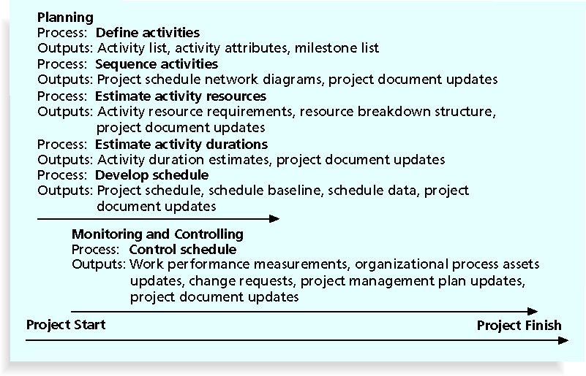

**Figure 6-3. Task Dependency Types**

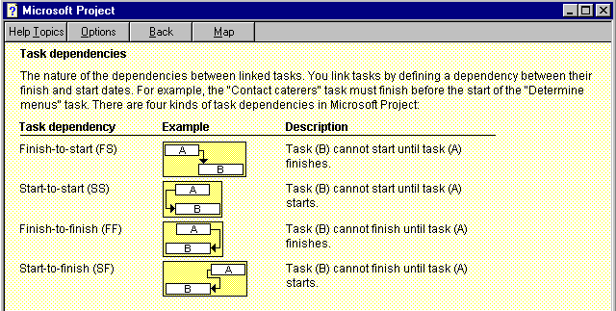

**Three-Point Estimates**

* Instead of providing activity estimates as a discrete number, such as four weeks, it’s often helpful to create a **three-point estimate**
  + An estimate that includes an optimistic, most likely, and pessimistic estimate, such as three weeks for the optimistic, four weeks for the most likely, and five weeks for the pessimistic estimate
* Three-point estimates are needed for PERT and Monte Carlo simulations

**Figure 6-6. Gantt Chart for Software Launch Project**

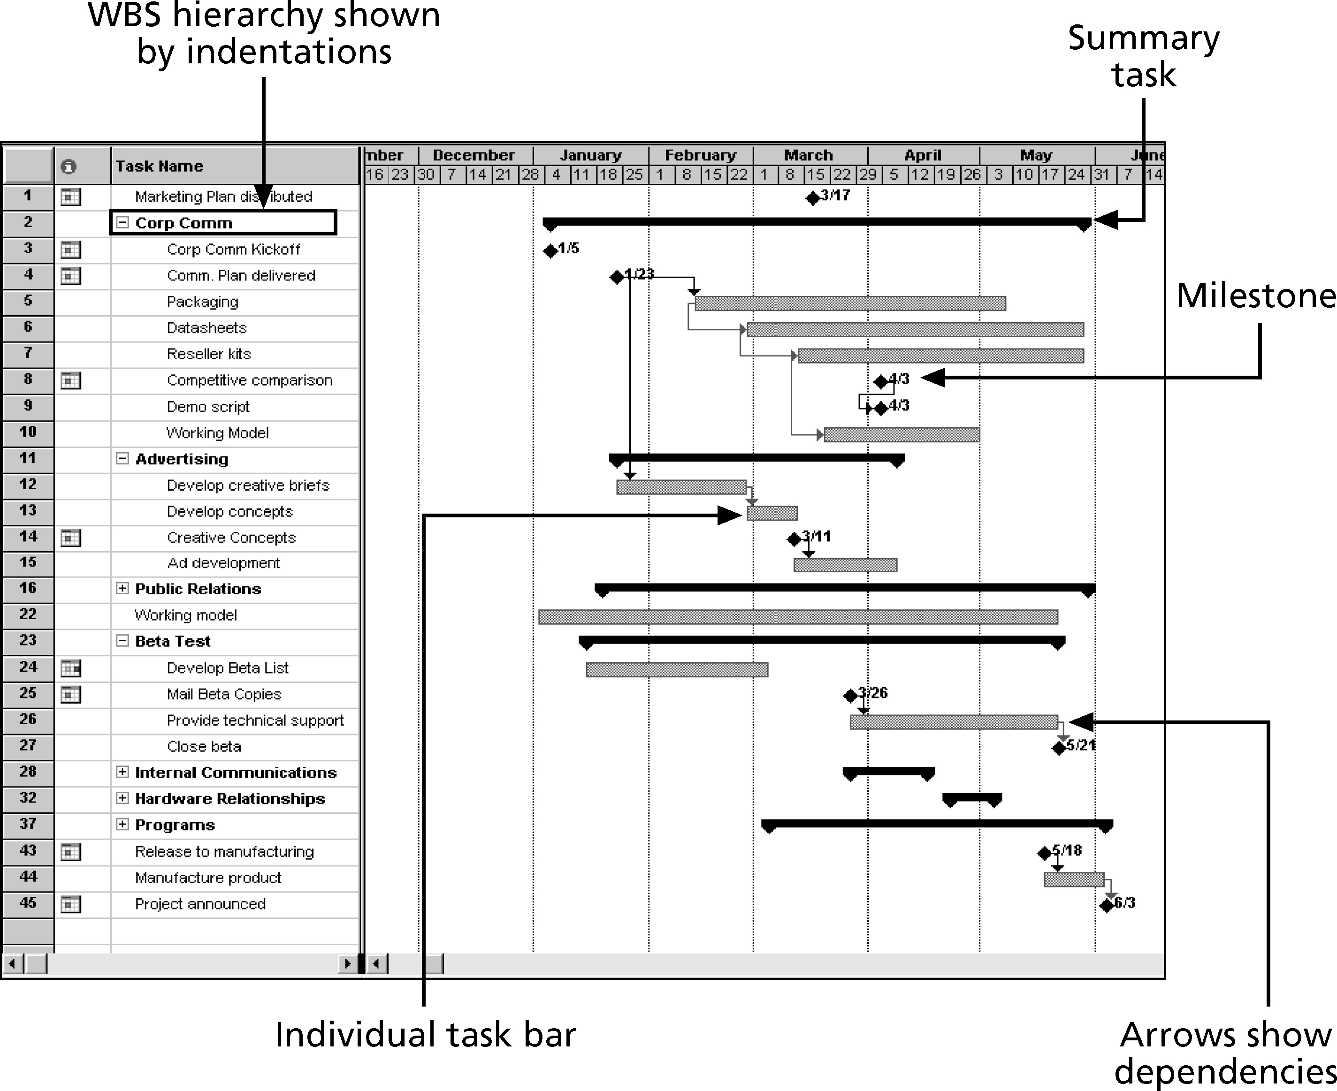

**Critical Path Method (CPM)**

* **CPM** is a network diagramming technique used to predict total project duration
* A **critical path** for a project is the series of activities that determines the *earliest time* by which the project can be completed
* The critical path is the *longest path* through the network diagram and has the least amount ofslack or float
* **Slack** or **float** isthe amount of time an activity may be delayed without delaying a succeeding activity or the project finish date

**Figure 6-8. Determining the Critical Path for Project X**

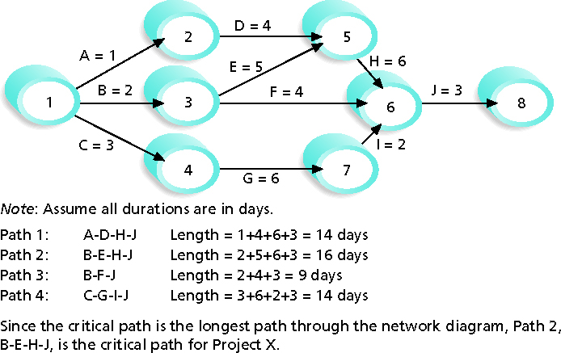

**PERT Formula and Example**

* PERT weighted average **=**

optimistic time + 4X most likely time + pessimistic time

6

* Example:

PERT weighted average =

8 workdays + 4 X 10 workdays + 24 workdays = **12 days** 6

where optimistic time = 8 days

most likely time = **10 days**, and

pessimistic time = 24 days

Therefore, you’d use **12 days** on the network diagram instead of 10 when using PERT for the above example

**Chapter 7: Project Cost Management**

**Project Cost Management Processes**

* **Estimating costs**: developing an approximation or estimate of the costs of the resources needed to complete a project
* **Determining the budget**: allocating the overall cost estimate to individual work items to establish a baseline for measuring performance
* **Controlling costs**: controlling changes to the project budget

**Earned Value Management (EVM)**

* **EVM** is a project performance measurement technique that integrates scope, time, and cost data
* Given a **baseline** (original plan plus approved changes), you can determine how well the project is meeting its goals
* You must enter actual information periodically to use EVM
* More and more organizations around the world are using EVM to help control project costs

**Earned Value Management Terms**

* The **planned value (PV)**, formerly called the budgeted cost of work scheduled (BCWS), also called the budget, is that portion of the approved total cost estimate planned to be spent on an activity during a given period
* **Actual cost (AC)**, formerly called actual cost of work performed (ACWP), is the total of direct and indirect costs incurred in accomplishing work on an activity during a given period
* The **earned value (EV)**, formerly called the budgeted cost of work performed (BCWP), is an estimate of the value of the physical work actually completed
* EV is based on the original planned costs for the project or activity and the rate at which the team is completing work on the project or activity to date

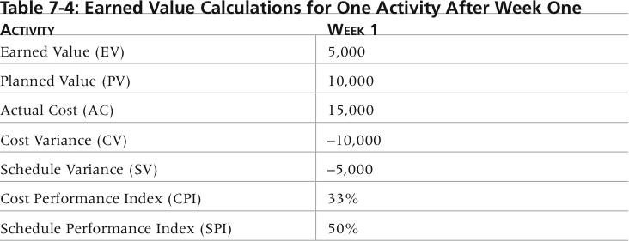

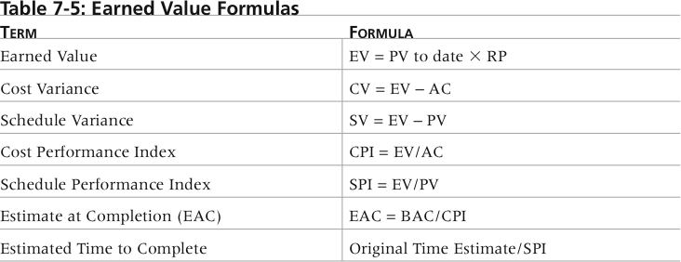

**Types of Tests**

* **Unit testing tests each individual component (often a program) to ensure it is as defect-free as possible**
* **Integration testing occurs between unit and system testing to test functionally grouped components**
* **System testing tests the entire system as one entity**
* **User acceptance testing is an independent test performed by end users prior to accepting the delivered system**

**Chapter 8: Project Quality Management**

**Performing Quality Assurance**

* **Quality assurance includes all the activities related to satisfying the relevant quality standards for a project**
* **Another goal of quality assurance is continuous quality improvement**
* **Benchmarking generates ideas for quality improvements by comparing specific project practices or product characteristics to those of other projects or products within or outside the performing organization**
* **A quality audit is a structured review of specific quality management activities that help identify lessons learned that could improve performance on current or future projects**

**Chapter 9: Project Human Resource Management**

**Figure 9-2. Maslow’s Hierarchy of Needs**

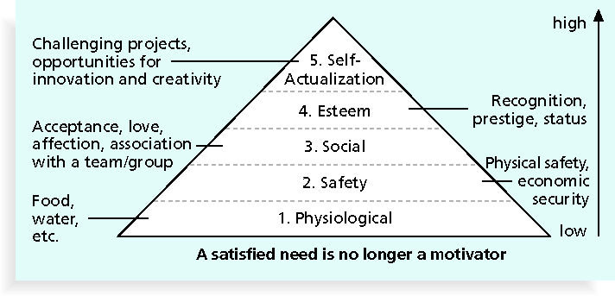

**Figure 9-3. Sample Organizational Chart for a Large IT Project**

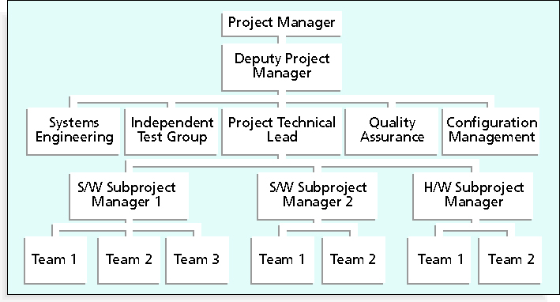

**Figure 9-4. Work Definition and Assignment Process**

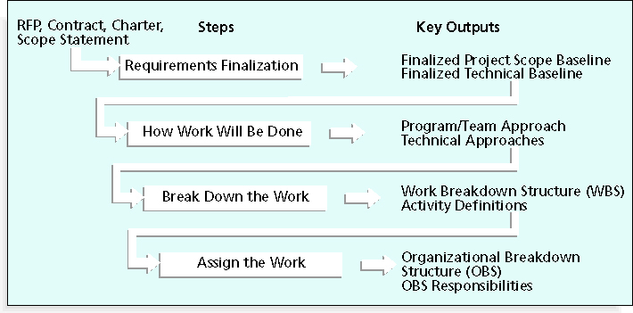

**Figure 9-5. Sample Responsibility Assignment Matrix (RAM)**

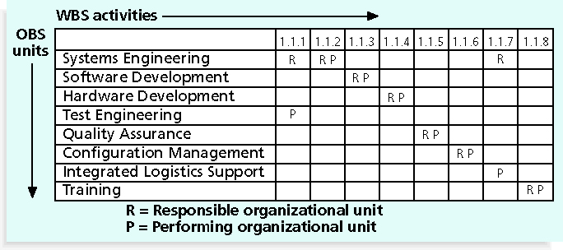

**Chapter 10: Project Communications Management**

**Project Communications Management Processes**

* **Identifying stakeholders**:identifying everyone involved in or affected by the project and determining the best ways to manage relationships with them
* **Planning communications**: determining the information and communications needs of the stakeholders
* **Distributing information**: making needed information available to project stakeholders in a timely manner
* **Managing stakeholder expectations**: managing communications to satisfy the needs and expectations of project stakeholders and to resolve issues
* **Reporting performance**: collecting and disseminating performance information, including status reports, progress measurement, and forecasting

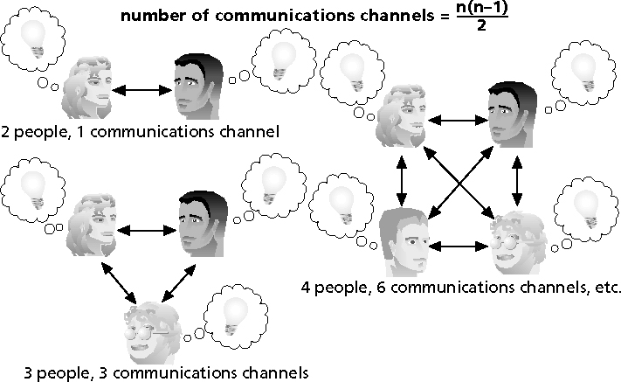

**Chapter 11: Project Risk Management**

**Risk Utility**

* **Risk utility** or **risk tolerance** is the amount of satisfaction or pleasure received from a potential payoff
  + Utility rises at a decreasing rate for people who are risk-averse
  + Those who are risk-seeking have a higher tolerance for risk, and their satisfaction increases when more payoff is at stake
  + The risk-neutral approach achieves a balance between risk and payoff

**Figure 11-2. Risk Utility Function and Risk Preference**

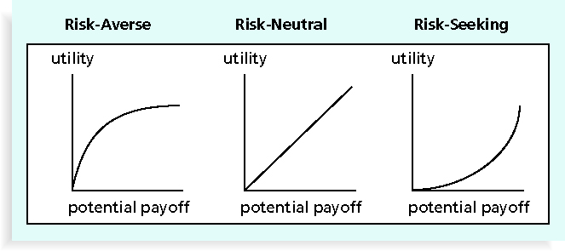

**Estimated monetary value (EMV)** is the product of a risk event probability and the risk event’s monetary value

**Figure 11-7. Expected Monetary Value (EMV) Example**

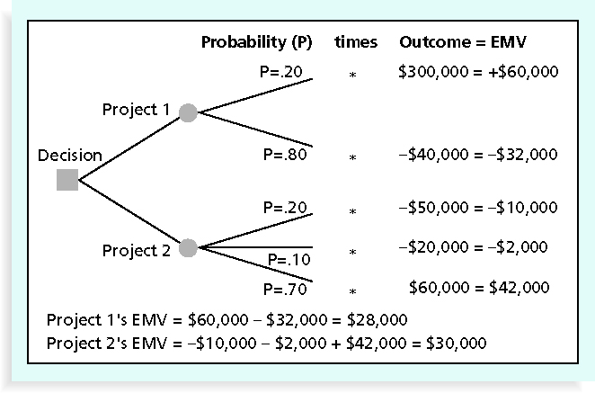

**Tools and Techniques for Planning Purchases and Acquisitions**

* **Make-or-buy analysis**: general management technique used to determine whether an organization should make or perform a particular product or service inside the organization or buy from someone else
* Often involves financial analysis
* Experts, both internal and external, can provide valuable inputs in procurement decisions

**Make-or-Buy Example**

* Assume you can lease an item you need for a project for $800/day; to purchase the item, the cost is $12,000 plus a daily operational cost of $400/day.How long will it take for the purchase cost to be the same as the lease cost?

**Make-or Buy Solution**

* Set up an equation so both options, purchase and lease, are equal
* In this example, use the following equation; let *d* be the number of days to use the item:

$12,000 + $400d = $800d

Subtracting $400d from both sides, you get:

$12,000 = $400d

Dividing both sides by $400, you get:

d = 30

* If you need the item for more than 30 days, it is more economical to purchase it

**Procurement Management Plan**

* Describes how the procurement processes will be managed, from developing documentation for making outside purchases or acquisitions to contract closure
* Contents vary based on project needs